Suject: DLD (Assignment 4)

Name: Zaeem Yousaf

Roll No: 19L-1196

Section: BCS-2E1

Submitted To: Ms Farah Munir

**Question 1:**

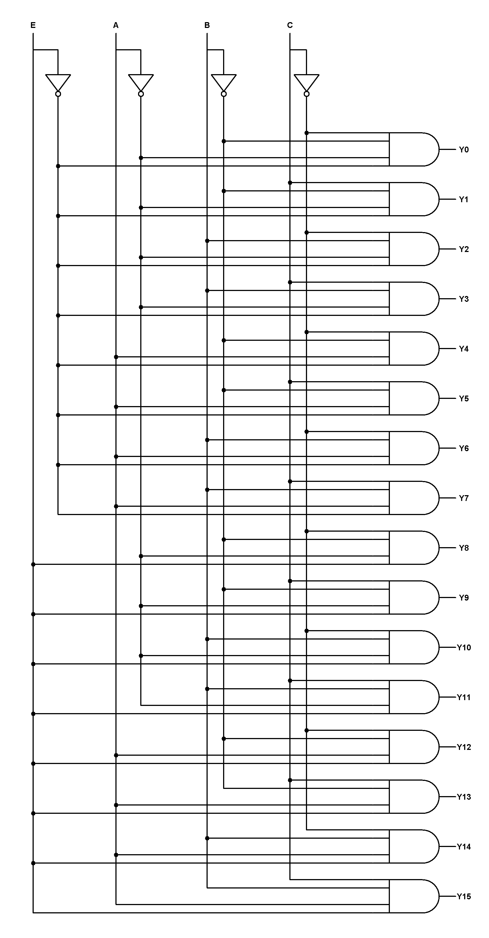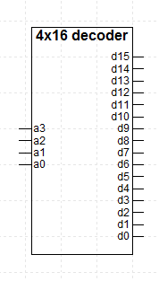**block diagram**



**Question 2**

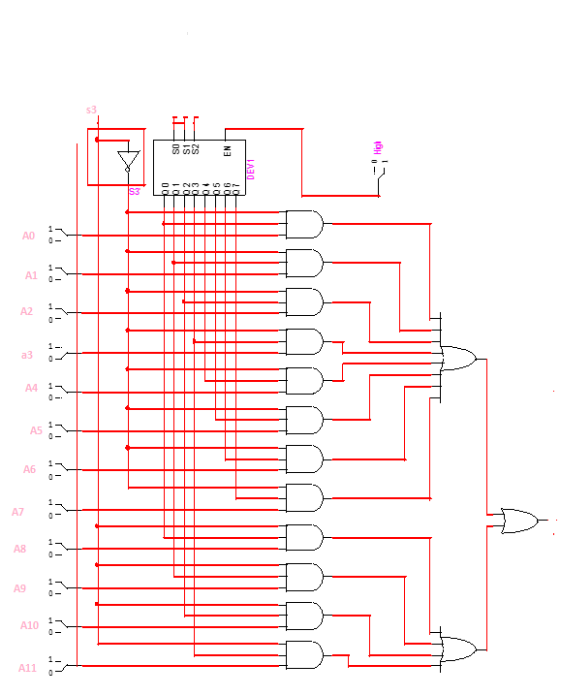

**Question 3**



**Question 4**

TRUTH TABLE:

|  |  |  |  |  |  |  |  |
| --- | --- | --- | --- | --- | --- | --- | --- |
| X | Y | Z | X+Z | (X+Z)' | F1 | F2 | F3 |
| 0 | 0 | 0 | 0 | 1 | 1 | 1 | 1 |
| 0 | 0 | 1 | 1 | 0 | 0 | 0 | 0 |
| 0 | 1 | 0 | 0 | 1 | 1 | 1 | 1 |
| 0 | 1 | 1 | 1 | 0 | 0 | 1 | 0 |
| 1 | 0 | 0 | 1 | 0 | 0 | 0 | 0 |
| 1 | 0 | 1 | 1 | 0 | 0 | 0 | 1 |
| 1 | 1 | 0 | 1 | 0 | 0 | 0 | 0 |
| 1 | 1 | 1 | 1 | 0 | 1 | 0 | 0 |

**Question 6**



F = AB'CD + A'BC'D' + AB(CD+CD'+C'D+C'D') + A'B'(CD+C'D)

F = AB + BC'D'+A'B'D + B'CD

F = ABCD' + ABC'D + ABC'D' + AB'CD +A'B'CD+ ABC'D'+A'BC'D'+ A'B'CD+A'B'C'D + ABCD

**Results:**

|  |  |  |  |  |
| --- | --- | --- | --- | --- |
| A | B | C | D | F=AB + A'B'D + B'CD + BC'D' |
| 0 | 0 | 0 | 0 | 0  1  0  1  1  0  0  0  0  0  0  1  1  1  1  1 |
| 0 | 0 | 0 | 1 |
| 0 | 0 | 1 | 0 |
| 0 | 0 | 1 | 1 |
| 0 | 1 | 0 | 0 |
| 0 | 1 | 0 | 1 |
| 0 | 1 | 1 | 0 |
| 0 | 1 | 1 | 1 |
| 1 | 0 | 0 | 0 |
| 1 | 0 | 0 | 1 |
| 1 | 0 | 1 | 0 |
| 1 | 0 | 1 | 1 |
| 1 | 1 | 0 | 0 |
| 1 | 1 | 0 | 1 |
| 1 | 1 | 1 | 0 |
| 1 | 1 | 1 | 1 |

**Question 7**



**Truth Table**

|  |  |  |  |  |  |  |  |  |  |  |  |
| --- | --- | --- | --- | --- | --- | --- | --- | --- | --- | --- | --- |
| S | A | B | Carry | S7 | S6 | S5 | S4 | S3 | S2 | S1 | S0 |
| 1 | 11010 | 10001 | 1 | 0 | 0 | 0 | 0 | 1 | 0 | 0 | 1 |
| 1 | 11110 | 1110 | 1 | 0 | 0 | 0 | 1 | 0 | 0 | 0 | 0 |
| 1 | 1111110 | 1111110 | 1 | 0 | 0 | 0 | 0 | 0 | 0 | 0 | 0 |
| 1 | 101001 | 101 | 1 | 0 | 0 | 1 | 0 | 0 | 1 | 0 | 0 |